
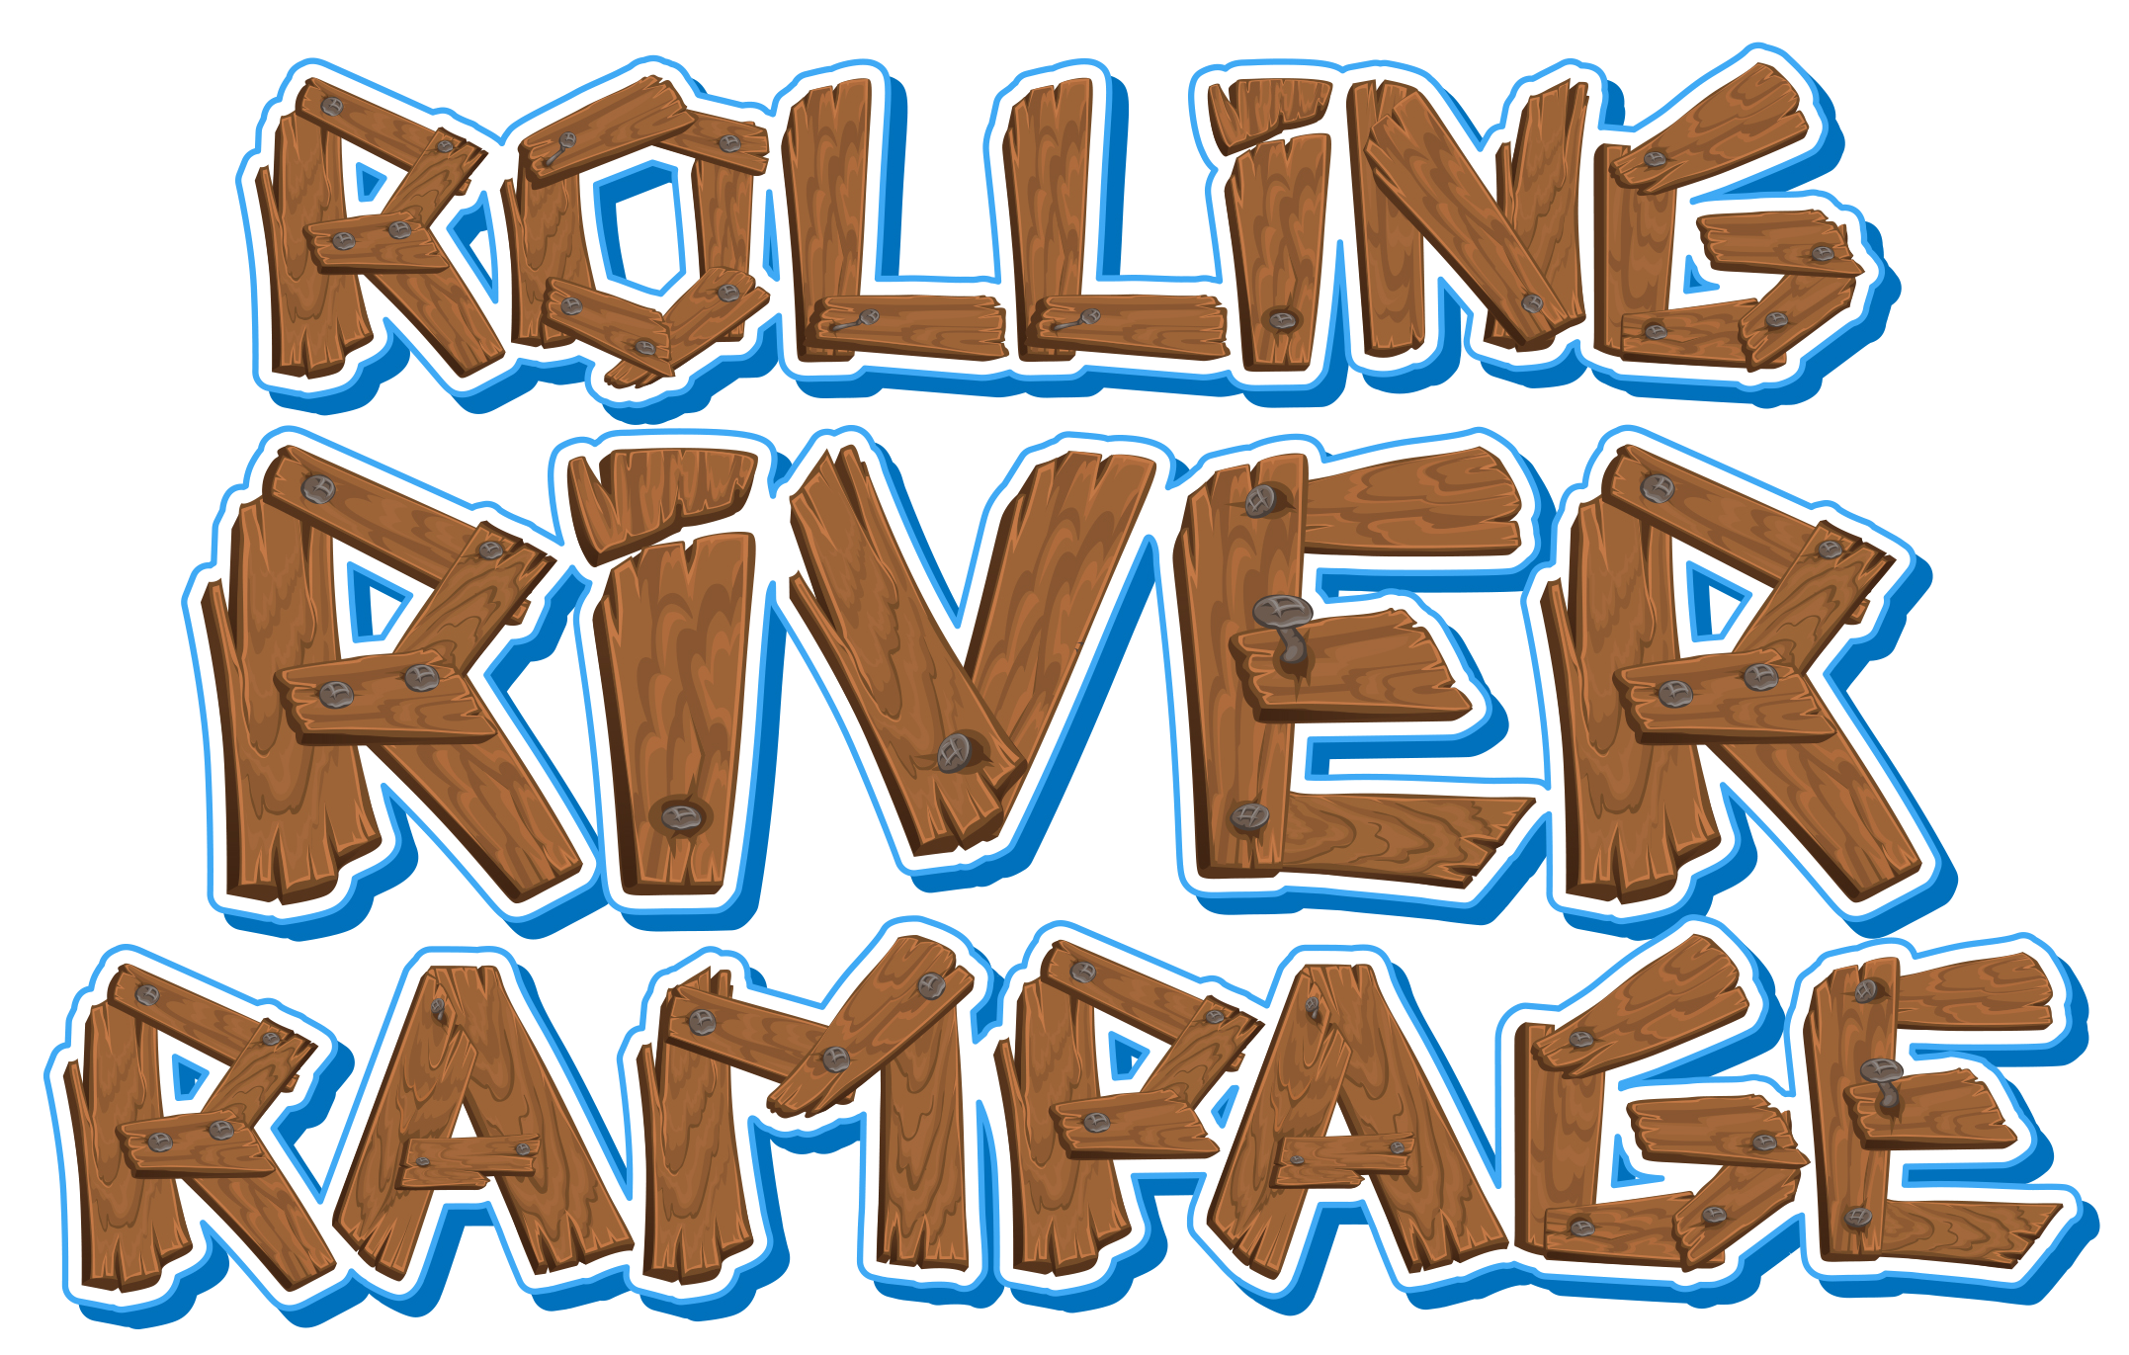
Vacation Bible School
Lakewood United Methodist Church

June 25 – June 28

9:00 A.M. – 12:00 P.M.

Children’s Ministry Coordinators:
Rochelle Gray & Jill Dillman (501-753-6186)
rgray@lakewood-umc.org jdillman@lakewood-umc.org

Rolling River Rampage:
Experience the Ride of a Lifetime with God!
During Vacation Bible School at Rolling River Rampage, your students will become Rafters and explore how to serve God and God’s mission for their lives. After a high-energy Opening Assembly, the Rafters make their way to the Bible Story Station. Interactive Bible lessons reveal Rapid Reminders to equip your Rafters for an active life with God. Your Rafters will discover a Rafting Ready Verse that will remain with them in their faith long after VBS. This white water adventure includes exciting new music, amazing science, creative crafts, fun recreation, and memorable Bible Stories that will help children know God is always with them as they ride the rapids of life.

For ages 3 years-to 6th Grade (Fall of 2018)
The age cut-off is August 1st. Your child must turn 3 by August 1, 2018 in order to be in the 3 year old class. Children should be potty-trained to attend the VBS.
Grade levels are for the coming school year, so enroll your child according to the grade they will be “going into” in the fall of 2018.
A nursery for infants and toddlers is available for VBS staff only.

Mission Focus for 2018: UMCOR (United Methodist Committee on Relief)
In the spirit of helping out communities stricken by disasters, our mission focus this year will be the United Methodist Committee on Relief. UMCOR works globally to alleviate human suffering and advance hope and healing. Donations will help provide support for families struggling to rebuild their lives after catastrophic events.

6th Grade Mission Maniacs
The 6th Graders (Fall 2018) will have a special emphasis on missions. Each day after opening assembly they will be learning about UMCOR as well as local groups that help during times of disaster. They will be doing a variety of projects to support the vision. They will also be doing some hands-on mission work during the week. This will require them to leave the church, so each 6th grader MUST complete a permission slip in addition to the registration form in order to participate in the field trip(s).
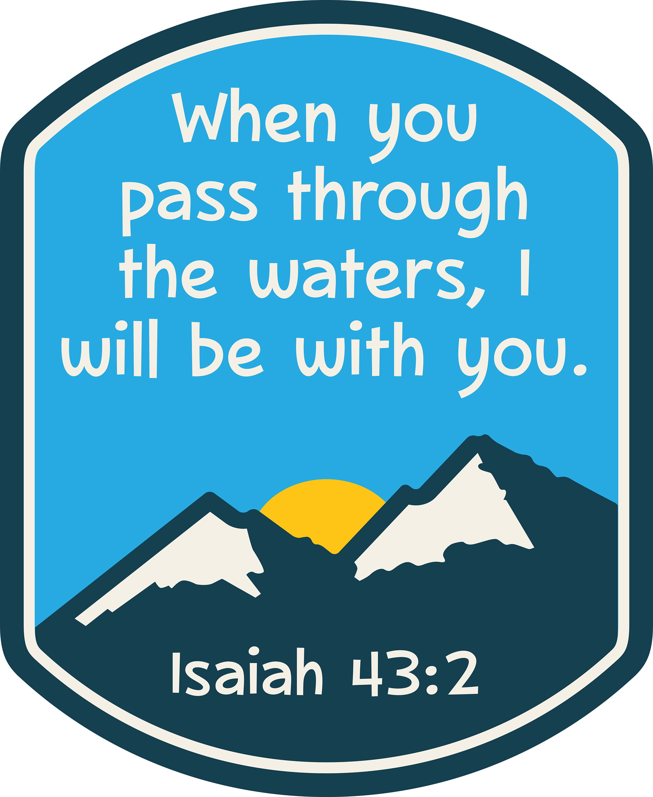
Closing Celebration
An exciting Closing Celebration is scheduled for Thursday, June 28 and is in the works. It will be a culmination of a week of learning how God’s Love is always with us. Stay tuned for more details.

Vacation Bible School 2018 Registration Form
Pre-registration is very important!
We are VERY appreciative of those who register early because it helps us plan properly for staff, volunteers, and projects.
To guarantee a t-shirt for your child, please return your registration form by Monday, June 4.
For more information call 753-6186 or e-mail rgray@lakewood-umc.org
For extra forms, please go to our church website at www.expandingthelight.org.

Please complete a separate form for each child including infants and toddlers of VBS staff workers.
Return to: Lakewood United Methodist Church, 1922 Topf Road, North Little Rock, AR 72116
(****For liability purposes, we are required to have a signed form for each child on site.****)

Child’s Name __________________________________________________ Sex M__ F___

Address ________________________________________________ Zip _________

Email Address (We will be sending most information by email.) ______________________________

Preferred Phone ________________ Alternate Phone ____________ Work Phone _______________

Birthdate _____________________ Current Age _________ Grade (Fall 2018) ____________

Parents’ Names ___________________________________ Church Home _____________

Emergency Name _________________________________ Phone ___________________

Allergies / Pertinent Medical Information ________________________________________________
T-Shirt Size Child YXS _____YS _____ YM _____ YL ______ YXL ______
Adult S _____ M _____ L _____ XL _____
***T-shirts can only be guaranteed if registration forms are received by Monday, June 4.***
I give my permission to LUMC to use photographs of my child in various media. ___Yes ___No

Would you be willing to volunteer at VBS? Yes _____________ No __________
Area of interest: _______________________ T-shirt Size: _____________
Release and Medical Authorization

I give _______________________________my permission to participate at Lakewood UMC during the Rolling River Rampage VBS, June 25-June 28, 2018. I fully understand the dangers and risks involved in the activities that my child will be participating in and will assume all responsibility of injury in connection with them, releasing and discharging LUMC, and the Counselors/Sponsors involved with this event, of responsibility. I understand that 6th grade children will be taking field trips and I give my permission for my child to be transported in the church van and/or bus. They will also need to fill out additional permission forms from the individual venues.

I also hereby give permission to Lakewood United Methodist Church and its agents to take the above named child to the Doctor, Emergency Medical facility, or Hospital, if in the opinion of employees or agents of Lakewood United Methodist Church, said child requires medical attention.

Signature of parent or legal guardian: _________________________________ Date: ___________________
Insurance company ___________________________________ Phone ______________________________
Employee’s Name ____________________________________ SS # ________________________________
Insurance ID Number __________________________________ Group # ____________________________

